Group number: 06

Name:
Ahmed Sattar 19p-1672
Hifza Majeed 19p-1652
Wahaj Tahir 19p-1673
Atif Mehrban 18p-0024
Muhammad Hassan 17p-6157
Organization name: Ran’aa Child Welfare Foundation (A Ray of hope)

Context of Report:
1.1: Decision Making
1.2: Planning
1.3: Strategic Management
1.4: Planning tool and techniques
1.5: Human Resource Management
RAN’AA CHILD WELFARE FOUNDATION (A RAY OF HOPE)
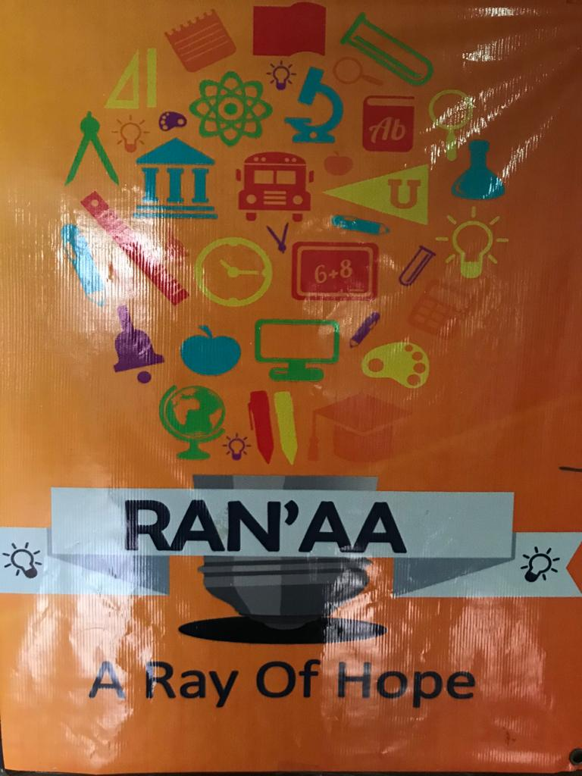
1.1: Decision-Making: The Essence of the
Manager’s Job

Identification of a Problem
In Ranna’s Foundation close due to COVID-19 so all thing close and teaching of student stopped so this problem here suddenly
Identification of Decision criteria:
- Try to reopening the foundation
- Conducting online using google meeting app

Allocation:
Try to reopening chance is less
conducting online but face many
connectivity issue on student side.
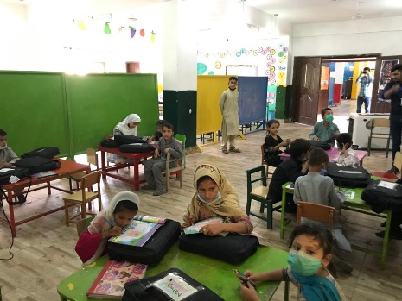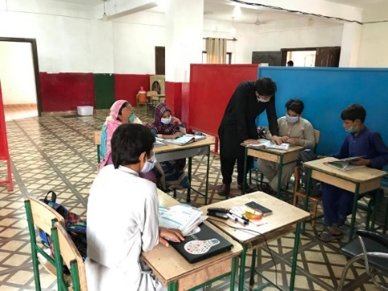

Analysis of Alternative:
Our team arrange a full open campus means to sit all the student have some distance and spread to each other
Selection:
The ECO and 2nd line manager decided Selecting the online teaching method
So all the student follow this decision

In decision making play the important role of ECO Mahesh and 2nd line manager.
Rationale Decision making:
ECO and 2nd and 1st line manager decided how to solve the problem all the manager provide her on opinion But ECO decide the best thing selecting for her foundation and student in other cases the ECO play an important role in decision making but Managers make decisions rationally, but are limited (bounded) by their ability to process information.
Intuition:
CEO make decision based their past Experience and she batter know how to solve the problem and she also face this problem but in other way so she decided to conducting a classes online
The ECO decision based on all the emotion and feeling and also to view her feeling to decide any thing

In my point of view,
they choose the recording lecture and also online and feather provide in hard form and collect daily base report The ECO also collect the and check the report of all the teacher working well or not.
Because I see in foundation and school, they send the work but not know the student doing her work properly and not show her interest.

Structured Problem and Decision:
The problem is here and the manager know how to solve them, and also prepare for any kind of problem. In this foundation some people come for visiting the foundation so many works are pending and the manager known how these works be done and which method to use how we work.
In these foundations when he starting face many problems because they teach the street child so now in this time, they known how to solve the problem

Decision-making Styles:
Decision making style of the CEO is conceptual 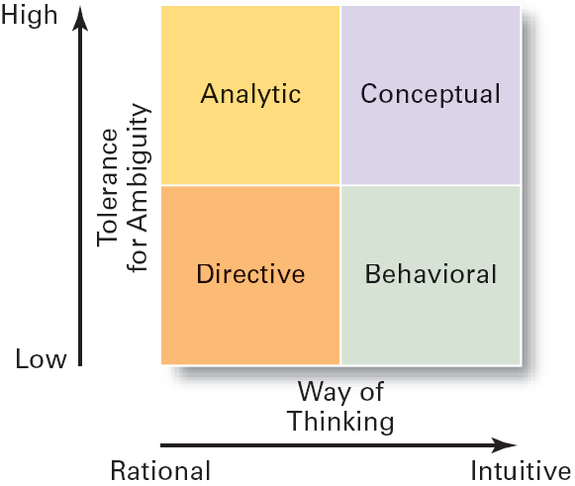
1.2: Planning:
- The goal of Rana,s foundation is to educate the children and also the labor child and help the needy and poor children.
- Their goal is to make parents aware of the education and make them able to educate their child instead of doing labor child.
- They take children from the roads and street and provide them with basic necessity of life like food and clothes and a little bit money as a reward.
- They hire teachers for the education and proper counselling of children and their parents as well as.

Purpose of planning:
- The purpose of Rana, s foundation is to guide the parents and educated labor child and poor children who can’t afford education.
- They guide their parents properly and accrue them that their child will educate and took admission in good school after getting his/her primary education from the foundation.
- They even don’t waste a little bit time of their children and also perform co-curricular activities so that a child groom. These all things are including in the planning of the foundation.

Elements of planning:
They provide a proper guideline to their students and see is that foundation completing the criteria of the performance.
They accomplished their goal by providing their students a proper and good education, two times meal and money as a reward.
People funded the organization and they make all their needs by the funds.
They meet all their expense by funding.

Types of Goals:
There are two type of goals
Financial goals
Strategic goals
- It will see that are funding of the foundation meeting the both ends of the financial needs or not. Can our foundation afford more children or not or we may go with them? Is that funding affords the current the students or not. These are all with the financial goals of the foundation.
- This goal is related with the other foundation that are standing beside the ranaa foundation. What are the things that are providing in the other foundation but not in ranaa? It will give a competition in the external environment.

Types of plan:
Strategic plan: it will see that organization is completing its goal or not and all the teachers are doing their task properly or what are things that can improve the entire foundation.

Operational plans: the ranaa foundation found seriously needed and poor child and take them to their foundation and
Provide them with basic necessity of life and do proper counselling of their parents and after primary education they admit them in good schools.

Long/short term plans:
Ranna foundation is not long-term plan neither short term plan they educate their children and admit them in good schools. They admit their children in good schools when they are able to get admission so it is not a long- term plan nor short-term plan.
Specific plan:
The plans of this foundation are clear that to educate needy and poor children.
Directional plans:
The directional plan of ranaa foundation is to make children educated and provide them with right path and make future of that labor child bright.

Management by objectives:
In this foundation both manager and employee agree to do the task because the purpose of this foundation is to educate. If they make any decision so the CEO and manager will agree on it. After successful progress they are awarded with rewards by the CEO. They all are giving their best for improvement of the foundation.

Conclusion and my point of view:

In my point of view this foundation is giving their best to reduce labor child from the society and make parents aware of the importance if the education so that they will make their children educated. This is a good way to reduce labor child from the society and make a good and educated society.
1.3: Strategic Management:

Ranna’s Foundation have a good hand when it comes to management responsibility for a long-term Mission. There are few things to keep in mind.
- Current Mission
- Goals
- Defining strategies

Current Mission:
Ranna’s Foundation main Mission is to educate and take care of the children who are poor, abuse, orphans, needed etc. To educate them, to groom them and make them a better person and for the country.

Goals:
Now the goals are the sub parts of main mission that how will you going to do it or what will steps you will set in order to achieve main mission and I have observer that they are really good at setting goals like they know their work and how they are doing and how to make it done in best ways by setting goals.
Strategies:
Strategies are made by looking “what you have and what will be needed”, In order to achieve a goal. The foundation has a very good and experienced stuff they plan very symmetrical about everything that how to make things done in best scenarios and built a strategy for it. I have observer it that they have a team work, they built and perform strategies together and execute them.

SWOT ANALYSIS OF Ranna’s Foundation:

S  STRENGTHS | W  WEAKNESSES | O  OPPORTUNITIES | T  THREATS
- Foundation has good and Experience staff.  - Top Manager level to bottom level manager they know their work very well.  - Team Work capability  - Management Skills,communication skills,Time Management.  - Responsibility  - Laptops and projector Technology  - Digital learning  - Quality Education | - Small Area  - Limited amount of students can be admit  - Government affairs on property  - old furniture  - out-dated Technologies  - Care taking of child must be improve  - Resources like limited amount of books and Laptops. | - If a employee is Student Then foundation pay 1semester fee of that student.  - Internship gives a good reputation on the CV.  - A person will be awarded with valuable certificates. | - Government is against not this foundation but the land where it is located.  - Parents hesitate while sending their children to foundation.

Formulating Strategy:

Strategy formulation refers to the process of choosing the most appropriate course of action for the realization of organizational goals and objectives and thereby achieving the organizational vision. In Ranna’s Foundation I have observe this strategy would not have much Importance as it should be given.

Setting Organization Objective:
As I told in Current Mission. The objective of this foundation is to help the child for better future.

Evaluating the Organizational Environment:
It is a Not loss,Not gain institute. So I don't think so it really have a competition with other institute,The foundation should discover its own strengthen and weakness.

Setting Quantitative Targets:
Try to set up the real goal in order to achieve the goal state and try to remain in the lane and focus. I think the foundation is on the lane and it is achieving its goals.

Performance Analysis:
Checkout the strategies you made to achieve the goal whither they are working fine or not if it they don’t then change the strategy. Management of Ranna’s Foundation are well skilled and they know what they are doing and how to do that.

Choice of Strategy:
IF the strategy is working after the analysis than go for the course of this strategy it will help you achieve the goals otherwise find new one.

Implementing the strategy:
After the formulating strategy and after getting the best analysis,Implement the best strategy you get it will help you to achieving goals successfully.

Evaluate the Results:
After all this action you will recieve the result which you apply early and save them for later it will help you to have a look back what what strategies you have performed.

1.4: Planning tool and techniques
Environmental scanning is check and it is balanced according to the environment.

Competitor intelligence allows to compete with others and its help the foundation to move next following steps to work hard to maintain the level.

Global scanning admires to control the outsider views and shows performance according to the main points.
Forecasting gives the prediction what come next most step to continue this work of the foundation .

Techniques are used for this to how the Quantity of the students allow in this foundation and how much we can handle easily.
On the other side Quality students required for the output and how much we can generate quality students and transfer them to others schools.
Benchmarking leads the competition level among them to show output and competitors show more hardwork to manage against it and impacts on the foundation.
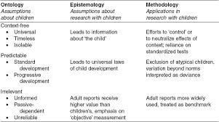

We can generate more outputs in this way against these competitors leads good work in that foundation.
Techniques are used for allocating resources in this way we can control most of levels in the foundation.
Financial requirements are check and balanced by manager in foundation.
Physically they are adjust their requirements used according to that need.
Human resources are check i-e skills,knowledge etc when they achquire a new staff member.
Budgets are to be set according to the last year spending amount in that foundation.
All the expenses revenues generated to be noted for the next moments.
For the foundation it is not necessary the fixed budget its almost variable budget .
Schedules are to arranged yearly what have to done this year and what cost of all this foundation have last year it shows the total budget.
It shows the coordination of various things used in foundation.
Techniques are used for these scheduling
Gantt chart which shows how much cost per year spend on foundation and it shows the individual work of each person.
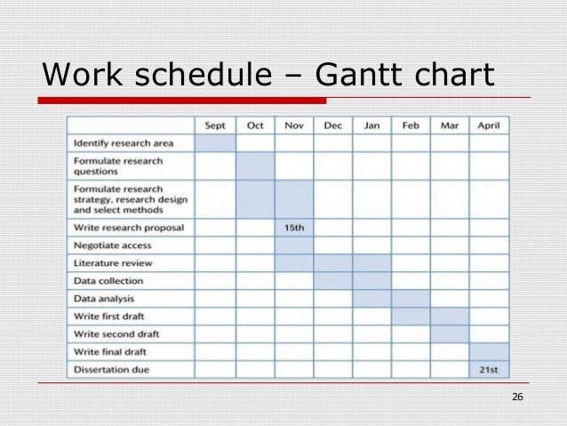

Load chart shows the individual task divided in horizental form to show some behavioural and each person have a record of each task.

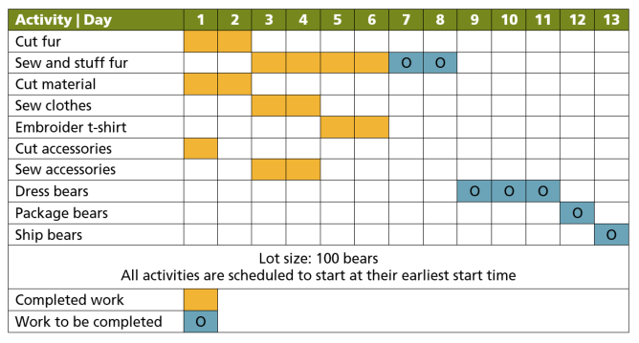

Breakeven anylysis after some time total expenditure cost and revenue generated on that base.

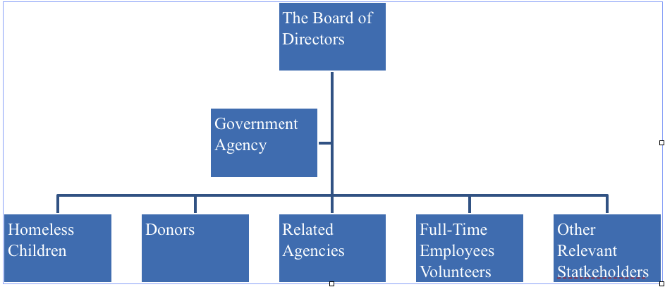
1.5: Human Resource Management

In the Ranaa’s Foundation, we noticed a few points related to Human Resource Management people are self-organized responsible and accountable for all or most aspects of making them better.

The Decision related to Recruitment, Recruitment Selection, etc are Centralized and the most important the proper setup of Human Resource Management (HRM). Employees in Foundation who performing their tasks effectively and efficiently. HRM used the Internet and E-Learning for Recruitment and Training Using Website, and Selection of Employees are based on their merit and skills Using Written Exams, Interviews, and some other methods according to Job Description.

HRM of Ranaa’s Foundation forecast the supply of employees and demand.

